Create 2 VPCs in same region or m different region and establish peering connection between them

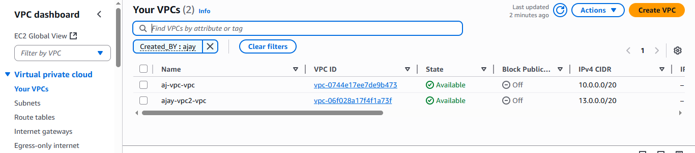
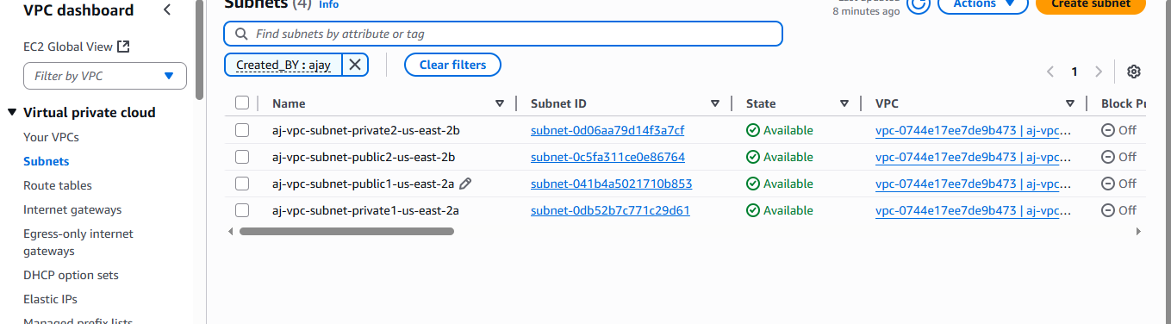

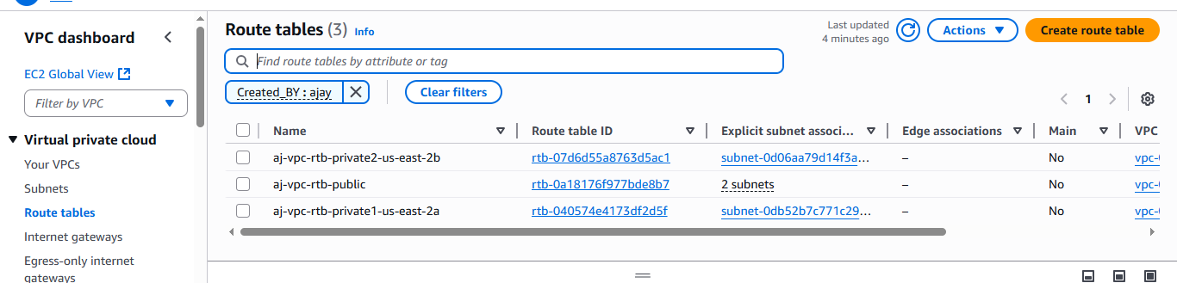

And establish peering connection between this 2 vpcs

Now create subnet group for databases.
Subnet group allows us to configure database,,so that we can configure database in that particular subnet VPC.
On rds console pagesubnet group

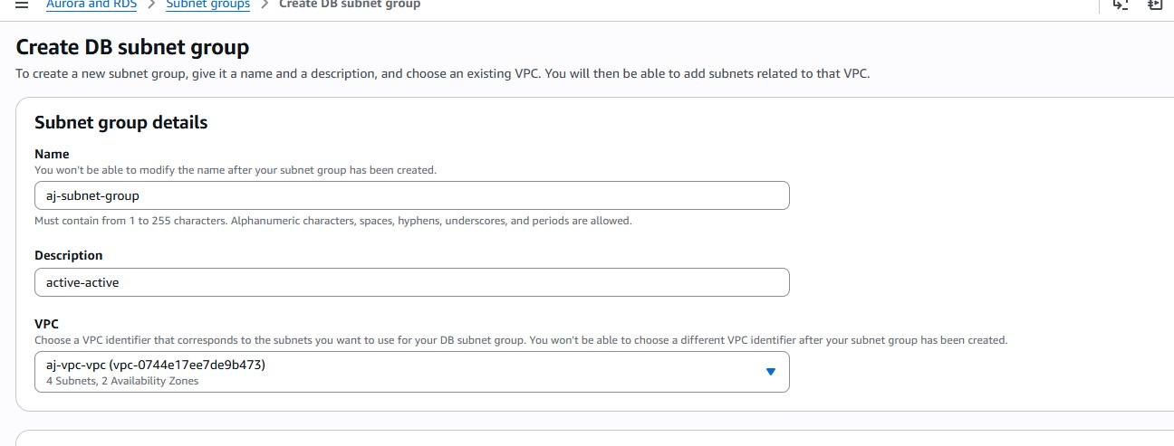

Choose vpc and private subnet in that database will get created
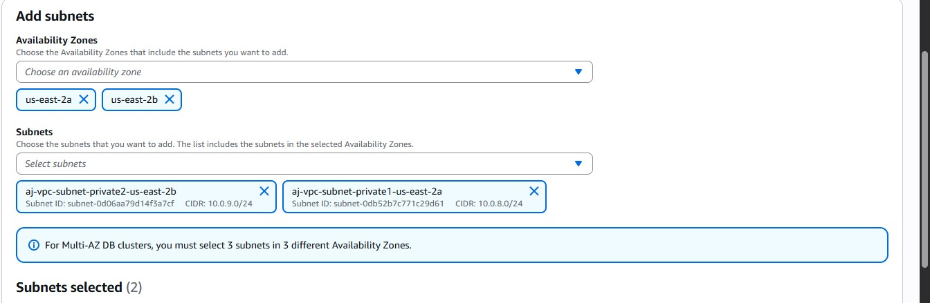

Do same for another vpc

Create 2 mysql database in their respective VPC
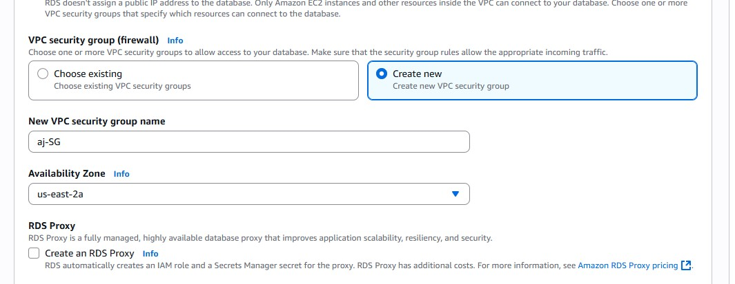

Create another database using another vpc (aj-vpc2)

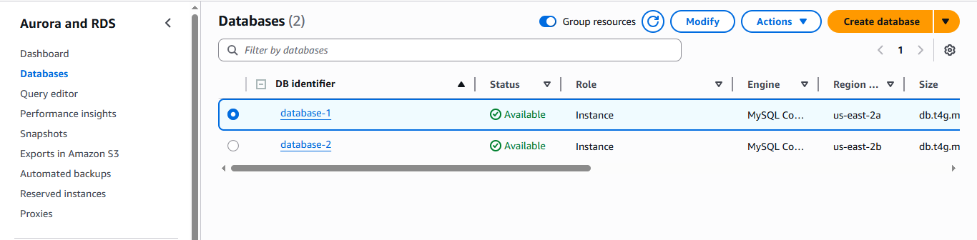

Now create a parameter group and this following changes
On rds console page parameter group (choose only mysql8 version)
After creating
parameter groupedit
Add this following configuration
1. ## in parameter group allow this settings
2.
3. rds.custom_dns_resolution=1
4. enforce_gtid_consistency=on
5. rds.group_replication_enabled=1
6. ## BY command SELECT UUID(); on one database is enough. no matter how many database you have.
7. group_replication_group_name=52ff010a-4069-11f0-b193-02f9cc4b5d31 ## BY command SELECT UUID();
8. gtid-mode=ON
9. ## configure all database endpoint in SEED
10. group_replication_group_seeds=database-1.cgkf5qiqs0zz.us-east-2.rds.amazonaws.com:3306,database2.cgkf5qiqs0zz.us-east-2.rds.amazonaws.com:3306
11. group_replication_start_on_boot=1
12. slave_preserve_commit_order=1
13. binlog_format-ROW
14.

For group_replication_group_name run SELECT UUID(); on any one dataset
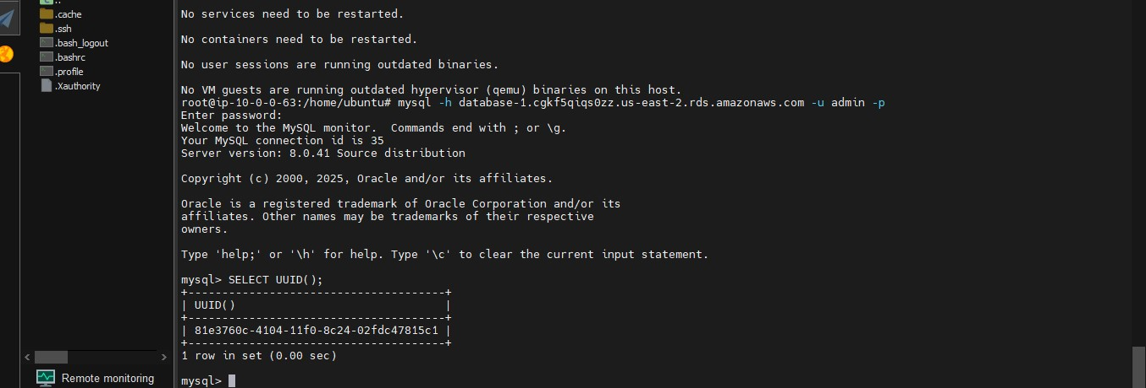
Add this in parameter group

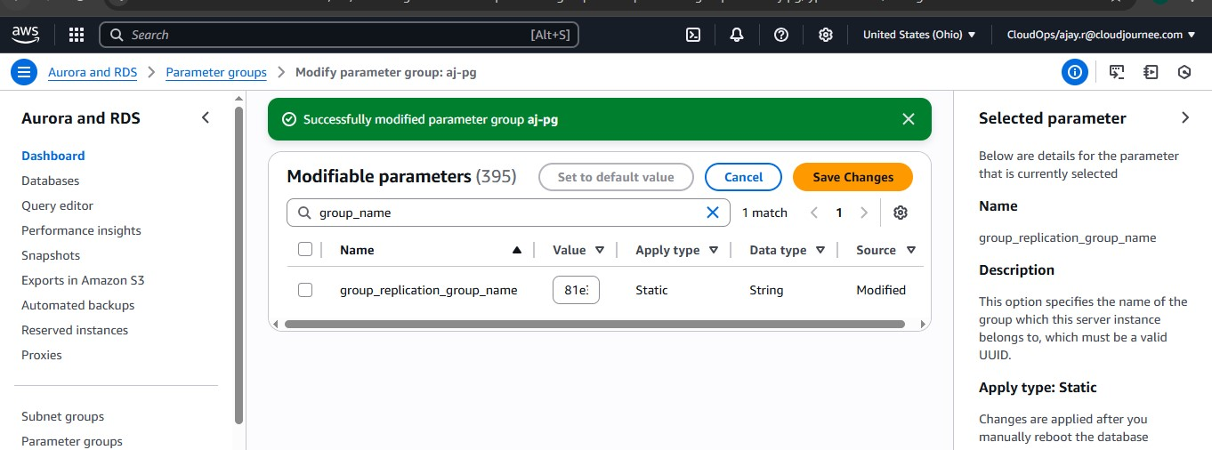

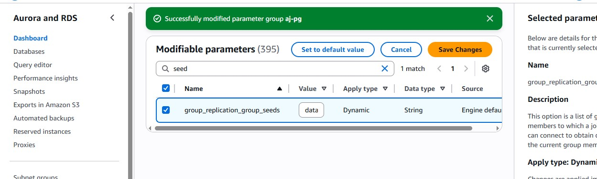

Attach this same parameter to both database
database1 modify and the parameter group confirm modify
database2modify and the parameter group confirm modify

Now enter to both databases and run this command on both
# login into all the database instance and set this possword for rdsgrprepladmin use
1. CALL mysql.rds_group_replication_create_user('MySecurePassword123!');
2. CALL mysql.rds_group_replication_set_recovery_channel('MySecurePassword123!');

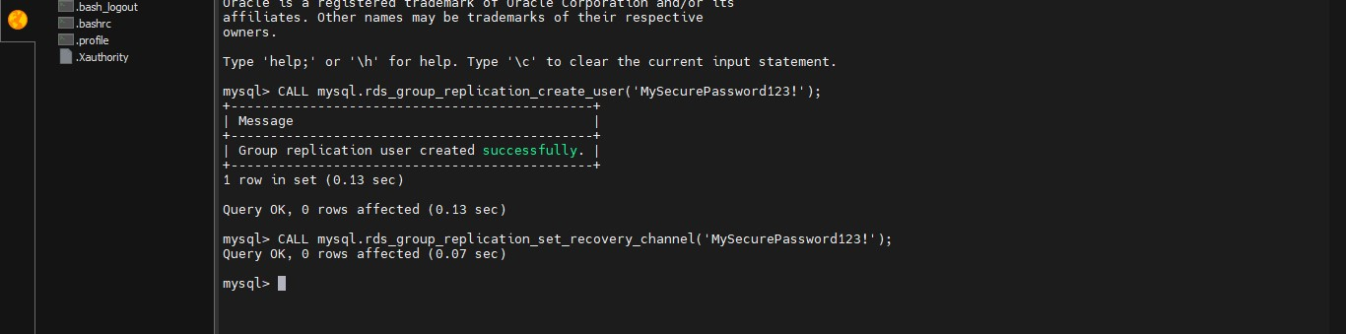

Use same password run this command in any one database
2. call mysql.rds_set_configuration('binlog retention hours', 168); -- 7 days binlog
3. call mysql.rds_group_replication_create_user('MySecurePassword123!');
4. call mysql.rds_group_replication_set_recovery_channel('MySecurePassword123!');
5. call mysql.rds_group_replication_start(1);

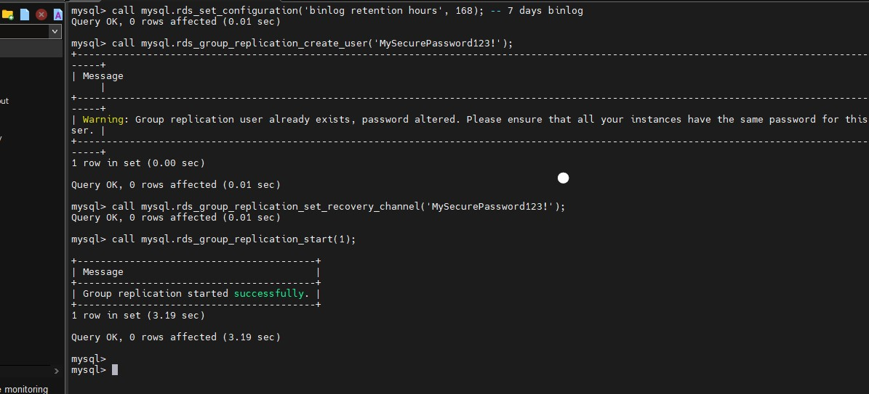
Run this command on another database
1. call mysql.rds_set_configuration('binlog retention hours', 168); -- 7 days binlog
2. call mysql.rds_group_replication_create_user('MySecurePassword123!');
3. call mysql.rds_group_replication_set_recovery_channel('MySecurePassword123!');
4. call mysql.rds_group_replication_start(0);
5.

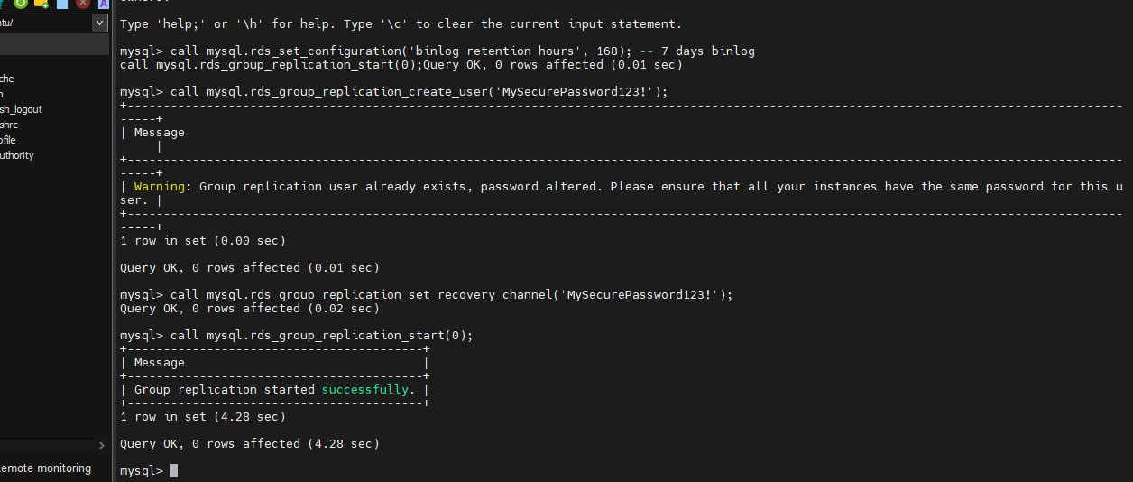

Now login into database 1 run this command
1. SELECT * FROM performance_schema.replication_group_members;

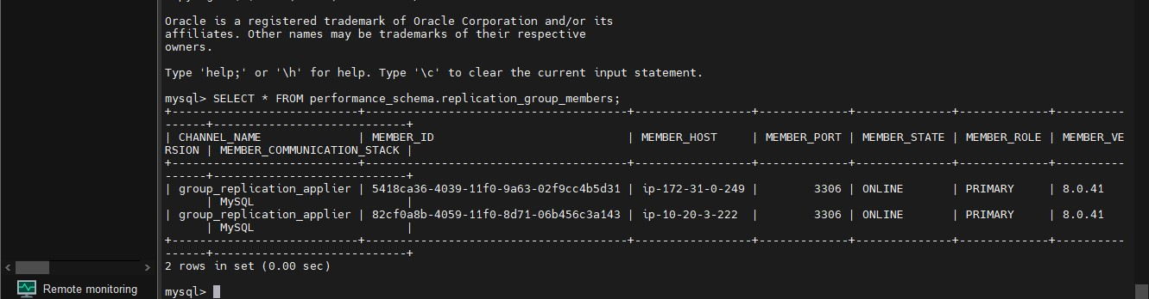

Now perform data operation like creating database named test_db and table table_test
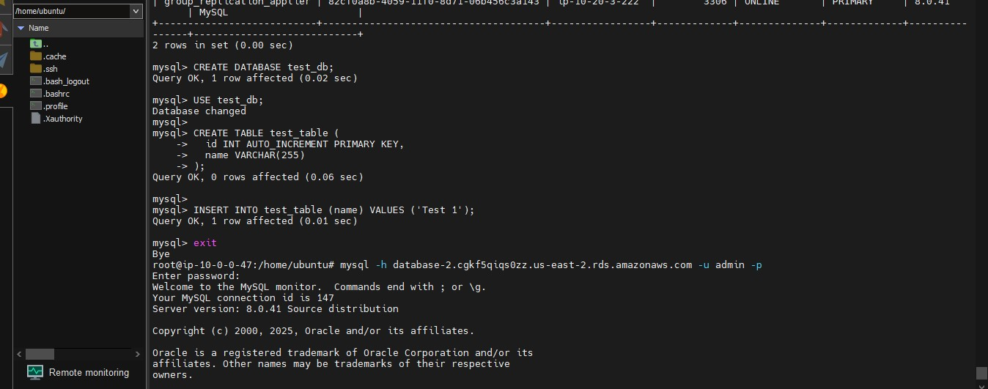
Login in database 2 see datas are automatically stored
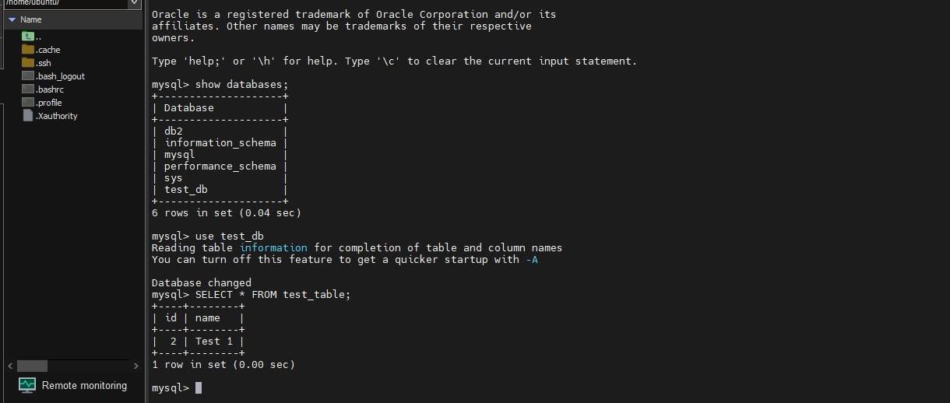

That’s it .

